Alexander/ Today’s Veterans Project
Provided below are links to valid resources that may be helpful in regards to Mr Alexander’s Epic/Veteran’s project. At the bottom of the page is information in regards to GCPS Research databases. Questions, see Ms Bird, the media specialist

LINKS

RESOURCES for Soldiers, Army families, families of the fallen
https://www.army.mil/article/123275/resources_for_soldiers_army_families_families_of_the_fallen
Stop Soldier Suicide
http://stopsoldiersuicide.org/about/
Veterans Crisis
https://www.veteranscrisisline.net/
National Institute of Mental Health
https://www.nimh.nih.gov/health/topics/post-traumatic-stress-disorder-ptsd/index.shtml
Survivor’s Guilt
https://maketheconnection.net/symptoms/guilt
Make the Connection
Website provided by the US Department of Veterans Affairs
https://maketheconnection.net/
Substance Abuse
National Institute on Drug Abuse—specific to soldiers
https://www.drugabuse.gov/related-topics/military

**See next page for valuable databases info**

DATABASES
Databases are accessed through MyEclass and are labeled ONLINE RESEARCH LIBRARY.
**NOTE** This is the BEST database to use for searching for the topics listed on the bottom of the assignment sheet. Using the advance search provides the best results. Make sure to change all 3 boxes at the top to KEYWORD. Also, once search results are displayed, do not miss the EVERYTHING box on the right
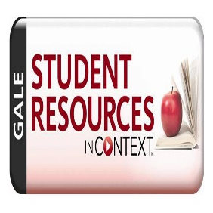
http://ic.galegroup.com/ic/suic/?p=SUIC&u=lawr16325

