Fisher/Modern Day Witch Hunt Research Project
Research is not meant to be easy; however, at the same time, it is not meant to be impossible. Research should be challenging and require work. Research requires the student to search, find and utilize MULTIPLE valid and credible sources and information to prove a point. The resources provided below provide valid and credible resources.
*WARNING* Searching the open web for your sources can lead to unsound sources. Unsound sources can be and most likely will be considered worthless by the instructor.

- Biography in Context
Still looking for a person you use in your paper? Use BIC to find biographical information and links to further resources on your topic/person.
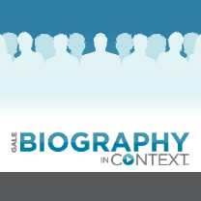
- Gale Student Resources in Context
Periodicals, reference books, multimedia, and primary sources provide information on people, places, authors, and books; includes timelines.
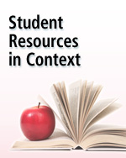
- ABC CLIO Issues: Understanding Conflicts in Society
Helps students develop an in-depth understanding of how society shapes and is shaped by controversy.
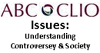

- Mas Ultra School Edition
Designed specifically for school libraries, this database contains popular full-text magazines, full-text reference books, biographies, primary source documents, photos, maps, flags, and color PDFs
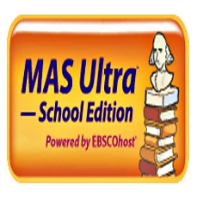

*All of these resources and more are available to access from My eClass under the Online Research Library Link. Passwords may be needed and are provided in MyEclass…see below*
